RMO ANNUAL REPORT
2024
info@rmo.org.af www.rmo.org.af



Contents
History 3
RMO board 4
Our Team and Departments 5
Forward from the board of trustees 6
Forward From Director General 7
What did we do in 2024? 8
WHAT IS OUR BENEFICIARIES SAYING? 16
RMO BACKGROUND 18
Main Donors 19
RMO Vision 19
RMO Mission 19
Relevance 19
Gender 19
Disability 20
Environmental sustainability 20

History
The Solidarité Afghanistan Belgique" (SAB) Program was originally set up in 1985 in refugee camps in Peshawar. Since 1992, it has gradually moved into Afghanistan itself, following the return of Afghan refugees and the progressive establishment of internationally recognized governmental structures. SAB concentrated on promoting the socio-economic empowerment of the most disadvantaged segments of the population, reaching women and men through projects in the fields of literacy and Vocational Training (VT) & Income Generation Activities (IGA), Agriculture & Livelihoods, and Education.
In 2008 SAB's Board and SAB senior Afghan staff jointly decided to gradually transfer SAB expertise, management, and implementation responsibilities to national staff and eventually change into a national NGO, in order to increase sustainability and local management capacities. Since then, senior staff has been taking over steadily increasing responsibilities in planning, implementation, and reporting. This concerned SAB's humanitarian and development projects, overall management, administration, and finances.
Since 2008 SAB gradually reduced the number of its expatriate staff and developed local capacities to fill the gap. The position of country manager was nationalized in early 2011, financial management in June 2012, and since November 2012 no expatriate staff was employed anymore in Afghanistan. Supervision and administrative support were still supplied by a director in Belgium and Board members in Europe.
In 2013 staff, management, and board jointly decided to finalize this transition by transforming SAB into a fully autonomous, national Afghan NGO. On 19-01-1393 (08-04-2014) RMO was officially registered with the Ministry of Economy of Afghanistan, under registration number 3170.
RMO retains the former national SAB management, key technical and administrative staff, and other SAB assets and maintains SAB expertise. It, therefore, is the trusted depository of SAB's nearly 30 years of experience and can smoothly continue all projects initiated under SAB management and take on any new challenges, while assuring the same project quality in these fields as SAB had provided for nearly 30 years.
As mentioned above, RMO collaborate with Geres from the very beginning of its establishment, based on this long experience and acquired skills, RMO will continue to work in the following fields:
- Agricultural Development, Livelihoods, and Food Security
- Energy Efficiency, environment protection, and climate change
- Vocational Training
- Civil Society
- Literacy & Education
- Humanitarian and Emergency Aid

RMO board
RMO board is contain of 4 national and 2 international members, who are committed to RMO development, make sure RMO projects and activities reach most vulnerable communities and needed people and are in line with RMO mandate and core business. Meanwhile the board of trustees have close monitoring of RMO annual budget, RMO relation with stakeholders and RMO team performance and behaviors.
Board Director
Abdul Raziq Hashimi

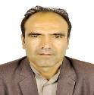

Board Member
Thierry Girard

M. Rafiq Sharifi
Board Member

Sultan Sikandar
Board Member

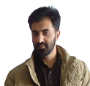
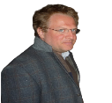
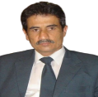
Board Member

Board Member

Our Team and Departments
Board of Directors includes six people (four national and 2 internationals
Zahra Hussaini
I born in Sar Asiab village of Bamyan province. I am working for RMO since April 2017. My role at RMO is scaling up awareness of Afghan local communities, especially Afghan women, local authorities and stakeholders on energy efficiency, environment protection and climate change adaption topics. Afghan communities are at too low level of awareness on mentioned topics, therefore together with my team and support of RMO management, we designed and developed comprehensive and context adapted awareness campaign, design and developed most appropriate tools and methodology for rural and urban context. of the country.

Management Team
Executive Director + 5 head of Departments

Admin/Finance Team include Admin/Finance Manager, Finance Officer, Admin/HR officer, logistic Officer, Support Staff (3 Guards, Cook, Cleaner and 5 Drivers

Wahidullah Anwarzai
I born on 27-03 1988 in Qala-e Shir Jan village of Maidan Wardak province. I join RMO Jan 2023. Although I worked for SAB for around 2 years. Since Jan 2023, I am working as training and business development supervisor with RMO. Together with my team, we designed, developed and large scale disseminated the most adapted and affordable energy saving solution for Afghan rural and urban context. these solutions are mainly included: Solar Verandas (4 model), Tandoor Cap, Improved Degdan, Solar Cooker, Biogas Digesters, Thermal Insulation Packages, Improved Green Houses and Cold Cellars.

Technical Department include: A team leader, field officers (5 person), awareness officers (3 people)

Monitoring and Evaluation Department include M&E supervisor, Data Energy officers, surveyors.
Executive Director + 5 head of departments

Research and Development unit include: R&D officer + support of RMO team and external consultancies

Vocational Training department
Vocational trainings were core business of Solidarité Afghanistan Belgique" (SAB), since RMO born in continuation of SAB mission in Afghanistan, therefore RMO have a strong background and experience on vocational trainings. Vocational trainings at RMO mainly include:
Agriculture Department
Under the supervision of agriculture specialist, the agriculture department at RMO is divided in two sections. 1) Agriculture infrastructures (green houses, cold cellars, fruit dryers….) 2) Food production and process unit

Forward from the Board of Trustees
RMO bord of trustees, representing by chairman closely follow RMO management, operations and relations towards key stakeholders. The board members are well aware of the challenging situation, and are satisfied by team performance in 2024, and express its cordial congratulation to the team at front line as well as on management and coordination levels. 2024 is marked a very successful year for RMO, as the team could able to independently run the first project after fewer years without partnering with any other NGO or organization.
We noticed, the last year has been one of contrasts, with staff doing all their efforts for success of the NGO and their assigned tasks. The board have been informed of the success, challenges and opportunities via several online meetings organized during the year long. As the board members, we’re hopeful that we’ll be able to meet in person in the year 2025 and share our views with RMO management and team. Turning Points’ continued ability to adapt and manage the ongoing activities at challenging situation and thanks to our committed staff for their outstanding performance at 2024. They have gone above and beyond to provide excellent services to clients during this difficult year on best of involved stakeholders satisfaction. Director General, head of departments, field teams and supports staff, charted a course through this difficult period and reached highlighted achievements. Special thanks to RMO female staff who performed outstanding achievements at very challenging environment. The director general and his team continued to empower the leadership, who have stepped up to take on more responsibilities on supporting RMO relations with donors, overseeing project implementations and maintain very good relations with key stakeholders. The leadership team has shown a tremendous ability to quickly implement energy and food security solutions project for most vulnerable communities of target areas. One perfect example of the staff’s ability to move forward is successfully implementation of energy and food solution project for peri urban Afghanistan and developed RMO relations with fewer donors and partners. This is one example of the stunning capability of the team. Additionally, the staff continues to show the vision necessary to see the needs of the community (both current and in the future) and find ways for the organization to smartly grow to meet those needs.
The board of trustees will remain supportive to the NGO management and field teams for further success and smoothly implementing projects and activities on the years to come.
Sayed Abdul Raziq Hashimi – RMO chairperson / board director

Forward From Director General
It has been my privilege and honor to work together with the team of professionals and committed members and honorable donors and stakeholders for the year 2024. I would like to state that 2023 was the year of challenges and hard work for RMO and our network of partners. Thanks to almighty Allah and commitment of our team, RMO successfully fulfil its commitments towards target groups, donor, line agencies and stakeholders. We finished 2024 with healthy revenue growth, prestigious deal wins and learnings. The challenges and lesson we learn from 2024 will for sure further improve ius for 2025, I am pleased to share that we are now well-settled into these new ways of working and remain resolutely focused on fulfilling our targets and beneficiaries needs.
In line with our strategic plan that was adopted in due to RMO mandate and our policies, RMO kept up its momentum and had its all projects aligned with its mission, vision, and strategic objectives. RMO projects and services bring changes to life of thousandths of most vulnerable country who suffer from poverty, climate shocks and economy issues. Our projects adopted innovative solutions for improving livelihood, economy and comfort of target communities via technical innovations on energy efficiency, food process and production and agriculture sectors.
The project implemented by RMO in 2024 were not only contractual obligations with donors and institutional partners but were also part of a social obligation it has established with the target communities. They were not only achieving targets and indicators set with donors but were also documenting best practices and learning from beneficiaries so that they could be used for better service provision in future. RMO team both at head office and field level did their best for greatly achieving the goals and set activities of 2024, meanwhile, the generous support of our great donor and partner institutions made all these achievements possible. Their technical, financial proved highly crucial in all accomplishments or our commitments during the year 2024.
We look forward to further achievements and supporting needy communities in 2025 which is possible with donors, communities and institutions collaboration and support.
Mohammad Riaz RAMIN- Director General
Rural Movement Organizations

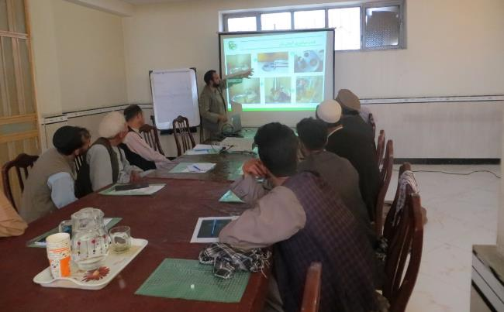
What we did in 2024?
Learning new profession give us more income options (said artisan)
49 artisans are trained on innovative energy saving solutions
25% income generation

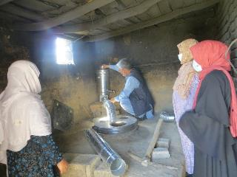
Practical trainings for female artisans
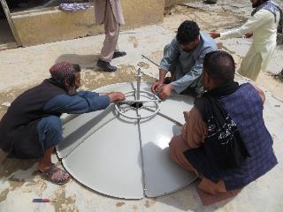
Practical trainings for artisans (installing solar Cooker)
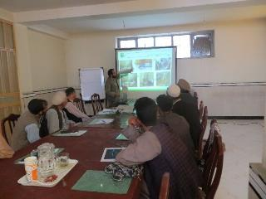
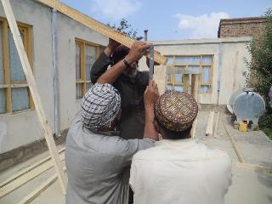
Theory trainings for artisans
Practical trainings for artisans
Energy Saving solutions, an average of 41% heating/cooling fuel saving, more comfort, improve health via avoiding indoor smoke and clean kitchen. In 2024, 55 unit of solar veranda, 135 unit of solar cooker, 100 unit of Tanddor cap and 36 unit of Improved Degdan has been disseminated.
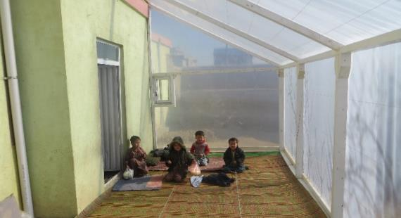
Solar veranda, save around 50% heating fuel, extra warm and light room in winter and improve indoor air quality and health of the users

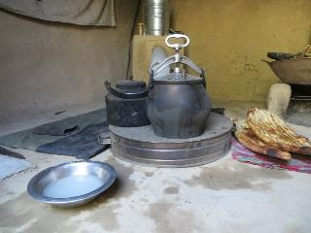
Tandoor cap, small innovation, reduce fuel, improve health of women and kids

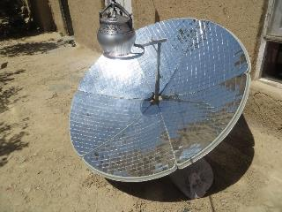
Solar cooker, fuel free technology

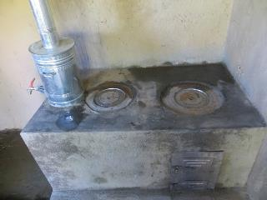

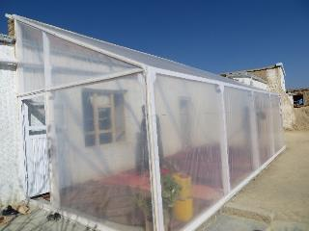
Veranda
Improved Degdan

Food process and production, at least 120 women are trained and supported for food process and production and creating small business via produced or proceed food items.
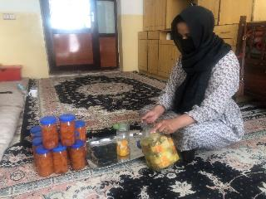
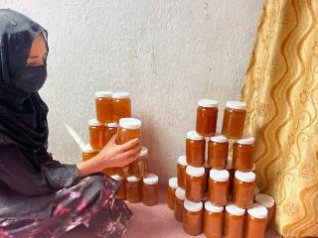
Jam Process
Jam Process

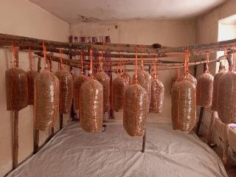
Mushroom production

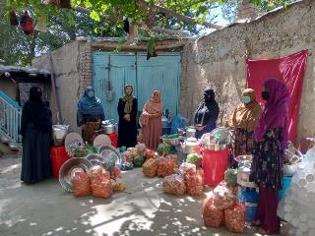
Women receive Toolkit and raw materials after trainings

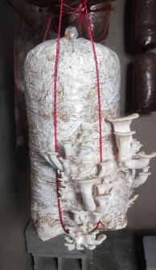
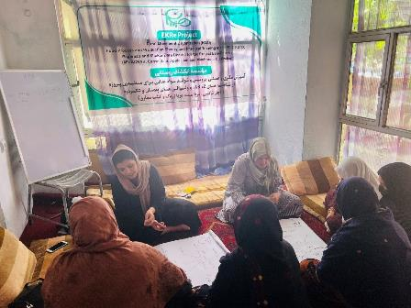
Mushroom production
Awareness raising provided to local communities about climate change impact, energy saving solutions and adaption to climate change impact. In 2024, 3551 women, 853 men received direct awareness and 135,000 people are informed through indirect awareness means.
Theory training to women on FPPs
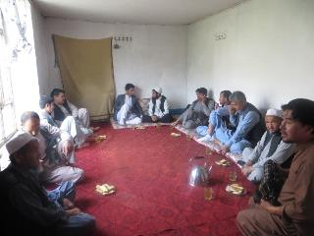
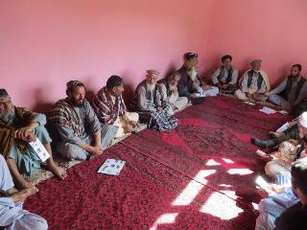
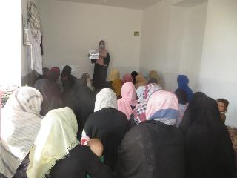

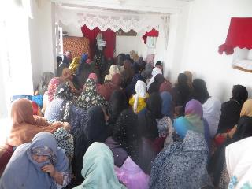
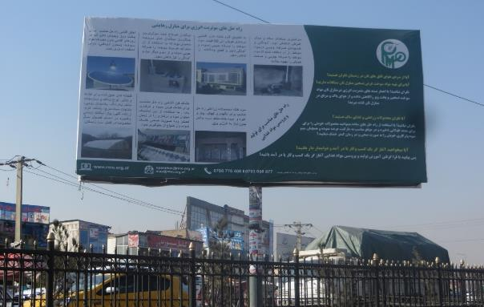
Project Banner (2024)
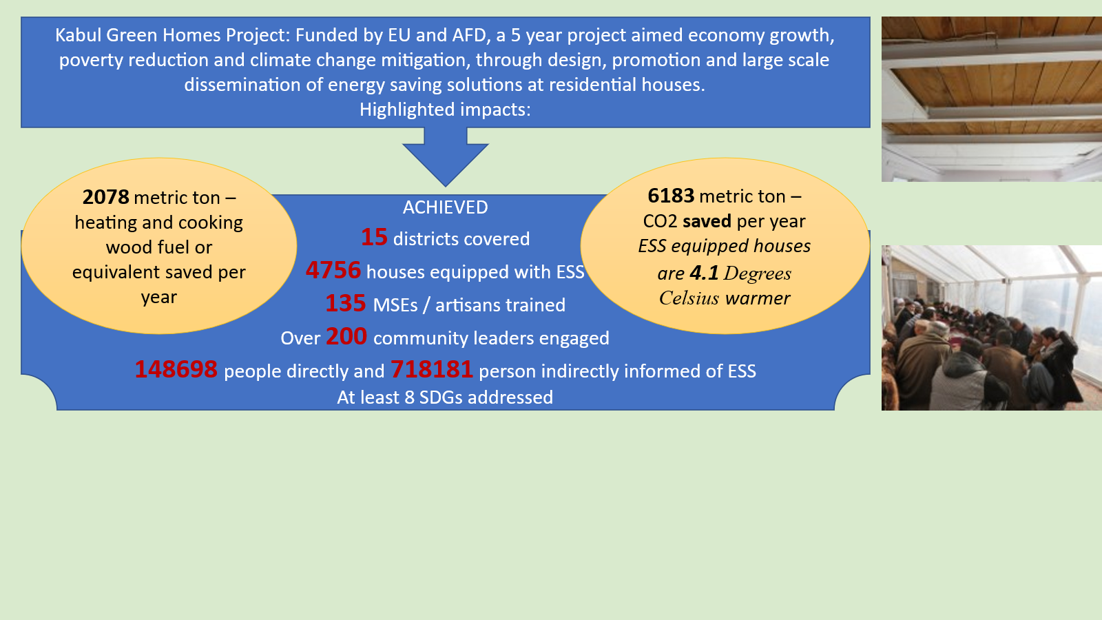
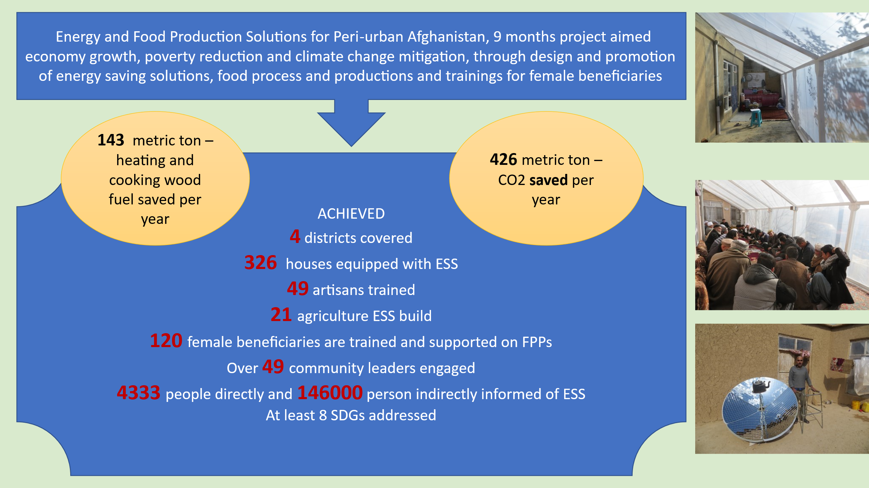
Project Example (2024)
Project Examples (2017-2022)
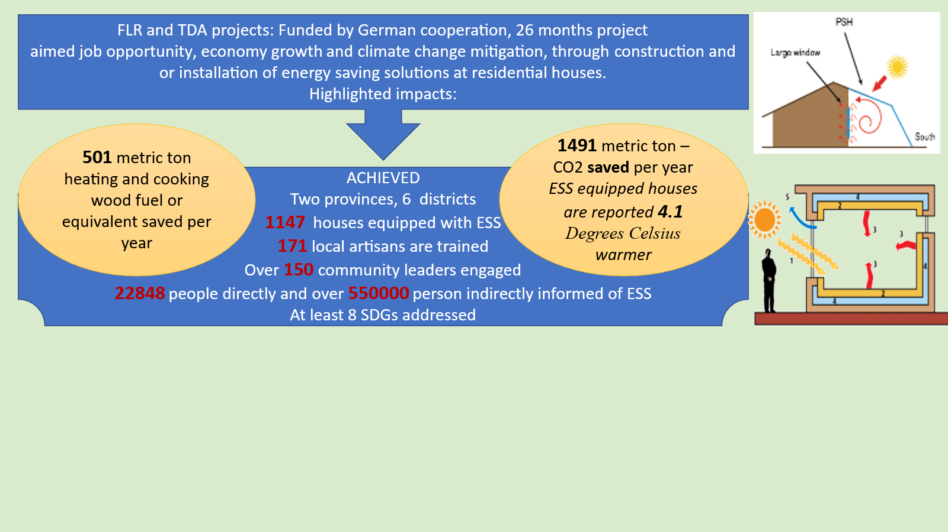
Project Examples (2020-2022)

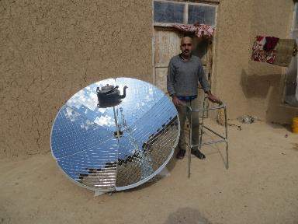
WHAT OUR BENEFICIARIES ARE SAYING?
Mr. Sefatullah, a resident of Shakar Dara district, who suffers from long-term illness and is unable to comfortably walk, received a solar cooker. He said to the project team, his family was dealing with several types of issues in providing their cooking and heating fuel such as cost, access, and smoke. He added they could not easily afford to buy fuel for heating and cooking, thus their family used tree branches, old clothes, and shoes and collected fuel from around areas. However, using biomass fuel in traditional cooling systems caused health issues for his wife and even kids, especially eye and breath issues due to indoor smoke and pollution. He was informed via community leaders about the RMO project and energy-saving solutions. He and his family immediately became interested in fewer energy-saving solutions, but their house could meet perfectly the criteria for a solar cooker. After the RMO team assessment, Mr. Sefatullah was eligible to receive a solar cooker. After having a solar cooker, he is very happy and appreciates RMO and the project, as at least 50% of his heating fuel was reduced, and of course its put positive impact on health of his family members. Finally, Mr. Sefatullah said, his kids saved the time collecting fuel and they save the amounts they were investing for buying fuel as well.
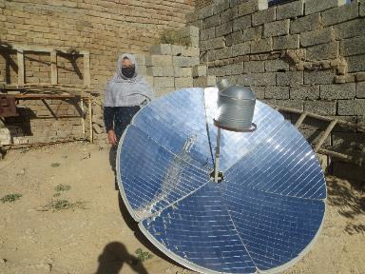
Together with her 6 children, MS Atifa is living at Chel Dukhtaran neighborhood of District 13 Kabul. She was awarded with a solar cooker. She highlighted to the project team her family were facing difficulties providing fuel for cooking and heating. Before receiving solar cooker, she cooks on traditional Degdan which work with wood or similar fuel and on oven which works with Liquid Petroleum Gas (LPG). Providing any kind of fuel was not easy for her family and neither accessible at their neighborhood. Since she received a solar cooker, she saves fuel and as well its more comfortable and smoke-free option. She makes most of the cooking during sunny days and boils needed water. She said now they need limited fuel to warm up the food for dinner and on cloudy/rainy days.
Thanks to donor financial support, the RMO team, and community leaders’ efforts in identifying and selecting the most eligible and vulnerable families, over 150 families received solar cookers in 2024. All of them express their happiness and satisfaction using the cooker.

RMO BACKGROUND
Rural Movement Organization (RMO) is an Afghan NGO with headquarters (HQ) in Kabul. It was established in 2014 as the continuation of the Belgian NGO "Solidarité Afghanistan Belgique" (SAB).
The SAB Program was originally set up in 1985 in refugee camps in Peshawar. Since 1992, it has gradually moved into Afghanistan itself, following the return of Afghan refugees and the progressive establishment of internationally recognized governmental structures. SAB concentrated on promoting the socio-economic empowerment of the most disadvantaged segments of the population, reaching women and men through projects in the fields of literacy and Vocational Training (VT) & Income Generation Activities (IGA), Agriculture & Livelihoods, and Education.
Since 2002 -when its main office and all its activities had been shifted to Kabul- SAB has implemented more than 35 literacy and VT, Agricultural, and Education projects in 11 provinces of Afghanistan: Kabul, Bamyan, Kapisa, Kunar, Laghman, Logar, Nangarhar, Nooristan, Panjshir, Parwan and Wardak.
In 2008 SAB's Board and SAB senior Afghan staff jointly decided to gradually transfer SAB expertise, management, and implementation responsibilities to national staff and eventually change into a national NGO, in order to increase sustainability and local management capacities. Since then, senior staff has been taking over steadily increasing responsibilities in planning, implementation, and reporting. This concerned SAB's humanitarian and development projects, overall management, administration, and finances.
Since 2008 SAB gradually reduced the number of its expatriate staff and developed local capacities to fill the gap. The position of country manager was nationalized in early 2011, financial management in June 2012, and since November 2012 no expatriate staff was employed anymore in Afghanistan. Supervision and administrative support were still supplied by a director in Belgium and Board members in Europe.
In 2013 staff, management, and board jointly decided to finalize this transition by transforming SAB into a fully autonomous, national Afghan NGO. On 19-01-1393 (08-04-2014) RMO was officially registered with the Ministry of Economy of Afghanistan, under registration number 3170.
RMO retains the former national SAB management, key technical and administrative staff, and other SAB assets and maintains SAB expertise. It, therefore, is the trusted depository of SAB's nearly 30 years of experience and can smoothly continue all projects initiated under SAB management and take on any new challenges, while assuring the same project quality in these fields as SAB had provided for nearly 30 years.
As mentioned above, RMO collaborate with Geres from the very beginning of its establishment, based on this long experience and acquired skills, RMO will continue to work in the following fields:
- Agricultural Development, Livelihoods, and Food Security
- Energy Efficiency, environment protection, and climate change
- Vocational Training
- Civil Society
- Literacy & Education
- Humanitarian and Emergency Aid
RMO trusts that its current and former partners, viz. donors, fellow NGOs, and other development organizations, Afghan government structures at national and local levels, as well as Afghan civil society will grant it the same trust and cooperation as they did for SAB.

Main Donors
RMO has extensively worked with the following donors:
French Embassy, European Commission (EC), Belgian Development Cooperation, Belgian Ministry of Foreign Affairs (MFA), GIZ, New Zealand Development Cooperation (NZAID), Australian Ministry of Foreign Affairs, UNESCO, UNICEF, UNHCR, UNDCP, IOM, FAO, the Ministry of Labor, Social Affairs, Martyred and Disabled (MoLSAMD) of past government and sub-contracted with Solidarités International (SI).

RMO Vision
Afghan communities effectively and sustainably manage their local resources for the improvement of their livelihoods. Afghans have sustainable jobs, comfortably live at their houses with clean indoor and outdoor air and they are less vulnerable to climate change impacts.

RMO Mission
As a qualified and experienced national NGO, RMO works all over the country to reduce poverty, support local economies, and mitigate climate change via the design, development, and implementation of projects and activities on, humanitarian, development, emergency response, and climate change/environment sectors.

Relevance
The board of directors is a mix of qualified and experienced Afghan and ex-pat staff, committed to supporting vulnerable peoples via a team of Afghan experts who have long experience on humanitarian, development, and emergency projects. RMO's understanding of the local socio-economic, environmental, geographical, and political context and the needs of the Afghan population help to design the most efficient projects. RMO encourages and involves the most relevant local society members and community leaders to increase their power over their own development by actively participating in all project phases. Therefore, its projects are well adapted to specific local needs, which enhances their effectiveness and sustainability.

Gender
Over 40 years of armed conflicts and recent climate change impact and natural disasters have increasingly marginalized the Afghan population, especially women and children. RMO believes in balancing gender participation and supporting women’s participation and benefits in all projects, particularly the female beneficiaries are under the deep attention of RMO projects and teams as they are the most affected categories. Whenever possible, RMO significantly increases its support to female beneficiaries, artisans, and MSMEs.

Disability
A particular effort is made to include disabled persons in RMO's humanitarian and development projects, in particular in skills training which can provide income-generating opportunities and reduce social exclusion.

Environmental sustainability
All activities are undertaken in such a way as to minimize negative impacts on the environment. Thus, training in the use of agrochemicals & fertilizers includes training in their safe application in order to ensure protection and better management of the natural environment, particularly water resources. RMO supports awareness, provides capacity development programs, and designed tools for environment-friendly practices and solution.
Financial Report

